1. Construct a Raspberry Pi model Robot system for HR system in an organization to assess an employee’s contribution. The system should take the following parameters as inputs:
- Self Appraisal
- Appraisal from Project Manager
- Achievements of the employee
- Awards and recognitions
- Feedback from clients
The model should assign a score based on the following factors. Each factor has a weightage of 20%. The decisions / actions should be based on the following:
Overall Score | Action / Decision
Score >80% | Can be considered for promotion
Score>50% and <80% | Monitor progress for 6 months and then take action
Score >30% and <50% | Counsel the candidate and take feedback
Score < 20% | Terminate the candidate

Identify the tasks and subtasks in the above process (Critical / non-critical / exceptional). Develop the python script for the same. No need to do the circuit simulation. Draw a block diagram of the model illustrating the components that would be used.

Ans:
- Python script:

#!/usr/bin/python

#Get the weightage out of 20% Self appraisal
def getWeightage_SelfApp(input):
if (input == 1):
return 4;
elif (input == 2):
return 8;
elif (input == 3):
return 12;
elif (input == 4):
return 16;
elif (input == 5):
return 20;

#Get the weightage out of 20% Appraisal from PM
def getWeightage_PMApp(input):
if(input == 1):
return 4;
elif(input == 2):
return 8;
elif(input == 3):
return 12;
elif(input == 4):
return 16;
elif(input == 5):
return 20;

#Get the weightage out of 20% : Achievements of employee
def getWeightage_Achivements(input):
if (input == 1):
return 5;
elif (input == 2):
return 10;
elif (input == 3):
return 15;
elif (input == 4):
return 20;

#Get the weightage out of 20% : Awards of employee
def getWeightage_Awards(input):
if (input == 1):
return 5;
elif (input == 2):
return 10;
elif (input == 3):
return 15;
elif (input == 4):
return 20;

#Get the weightage out of 20% : Customer feedback
def getWeightage_ClientFeedback(input):
if (input == 1):
return 5;
elif (input == 2):
return 10;
elif (input == 3):
return 15;
elif (input == 4):
return 20;

num_of_emp = int(input("Enter the number of employee(s) : "));

List_name = [];
List_score = [];
List_action = [];

for i in range(0,num_of_emp):

Emp_id = int(input("\nEnter Employee Id : "));
Emp_name = raw_input("Enter Employee name: ");

print("\n| Self Appraisal |");
SelfRating = int(input("Enter rating(1-5) of the self appraisal: "));

print("\n| Project Manager Appraisal |");
App_PM = int(input("\n\nEnter contribution type :\n 1. Unsatisfactory\n 2. More contribution needed\n 3. Highly valued\n 4. Excellent \n 5. Oustanding\nEnter : "));

print("\n| Employee Achivements |");
Achivements = int(input("\n\nEnter Achivement type :\n 1. The Shining Star\n 2. Top Performer\n 3. Best Team Player\n 4. The Innovator\nEnter : "));

print("\n| Employee Awards |");
Awards = int(input("\n\nEnter Awards type :\n 1. Spotlight Award\n 2. Customer Service Award\n 3. Best Leadership Impact\n 4. Employee Excellence Award\nEnter : "));

print("\n| Customer Feedback Type |");
Cust_Feedback = int(input("\n\nEnter Customer Service type :\n 1. Circle of joy award\n 2. Star Service Award\n 3. Platinum Service Award\n 4. Diamond Service Award\nEnter : "));

SelfRating = getWeightage_SelfApp(SelfRating);
App_PM = getWeightage_PMApp(App_PM);
Achivements = getWeightage_Achivements(Achivements);
Awards = getWeightage_Awards(Awards);
Cust_Feedback = getWeightage_ClientFeedback(Cust_Feedback);
Total_score = SelfRating + App_PM + Achivements + Awards + Cust_Feedback;

if(Total_score > 80) :
action = "%s should be considered for promotion" %Emp_name;
elif(Total_score>50 and Total_score<80):
action = "Monitor the progress of %s for 6 months and then take action" %Emp_name;
elif(Total_score>30 and Total_score<50):
action = "Counsel %s and take feedback" %Emp_name;
elif(Total_score<20):
action = "Terminate %s with immediate effect" %Emp_name;

#print "\n";
#print "Employee name -> %s | Score -> %d | Action -> %s " % (Emp_name,Total_score,action);
#print "\n";

List_name.insert(i,Emp_name);
List_score.insert(i,Total_score);
List_action.insert(i,action);

#print List_name
for i in range(0,num_of_emp):
print "\n %d. | Employee name - %s | Score - %d | Action - %s |" % ((i+1),List_name[i],List_score[i],List_action[i]);

- Tasks:
T1 - Submission of Self Appraisal
T2 - Appraisal from Project Manager
T3 - Achievements of the employee
T4 - Feedback from clients

- Scheduling Algorithm:

The Earliest Deadline First(EDF) algorithm is a priority driven algorithm in which higher priority is assigned to the request that has earlier deadline, and a higher priority request always pre-empts a lower priority one.

- Cheddar Screenshots

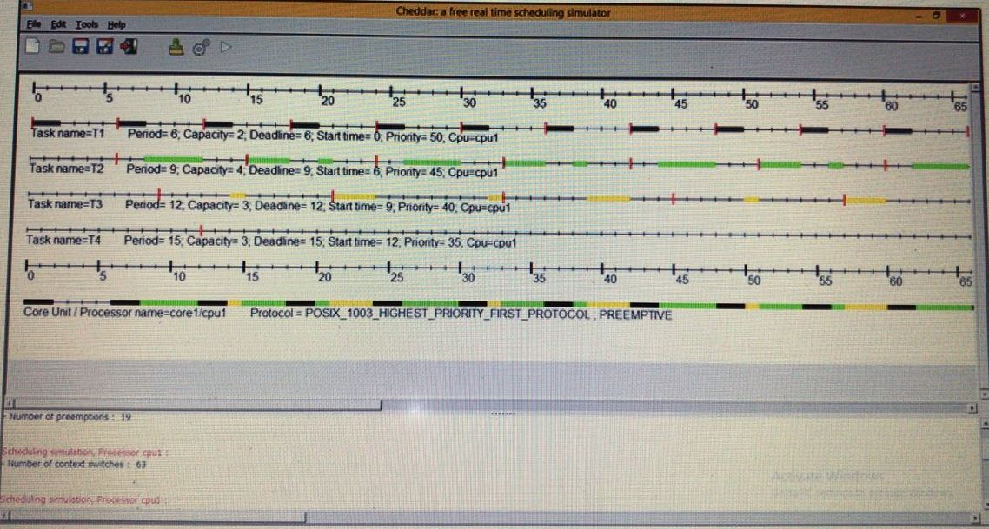

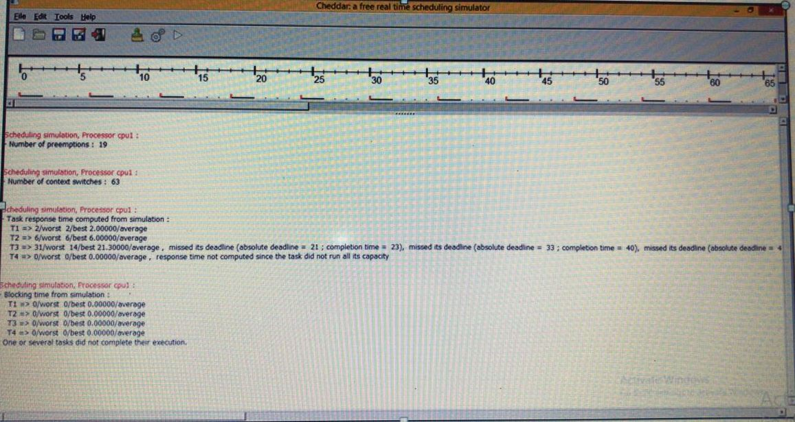

- Block diagram of model
